**Chapter 1**

**Introduction**

The project focuses on developing an **Inventory Management System** to streamline the management of inventory for businesses. Traditionally, inventory was managed manually, leading to inefficiencies, inaccuracies, and delays. This system automates inventory tracking, procurement, and reporting processes, ensuring a seamless and efficient workflow. It eliminates common bottlenecks and allows businesses to scale their operations with minimal effort.

By using this software, businesses can effectively monitor stock levels, manage procurement, and generate detailed reports for decision-making. The system provides an intuitive interface for users to access and update inventory records, ensuring a user-friendly experience. It helps businesses maintain optimal stock levels, preventing overstocking and understocking situations that often lead to financial losses.

The system is modular, covering various aspects of inventory management:

1. **Admin Module:** Manages users, roles, and system settings, providing security and streamlined access control.
2. **Product Module:** Manages product details such as categories, stock levels, and suppliers, offering real-time inventory visibility.
3. **Supplier Module:** Manages supplier information and purchase orders to streamline procurement processes.

This Inventory Management System ensures efficient tracking, minimizes manual errors, and improves overall productivity. It is designed to adapt to the needs of various industries, making it a versatile tool for businesses of all sizes.

**Chapter 2**

**Software Requirements Specification (SRS)**

**Purpose**

The **Inventory Management System** is designed to automate and improve inventory control, procurement, and reporting processes. It helps businesses optimize stock levels, avoid overstocking or understocking, and enhance decision-making based on accurate data. The system is built to increase operational efficiency while providing a robust platform for managing complex inventory needs.

**Document Conventions**

The document follows IEEE SRS standards, and formatting adheres to established norms for readability and consistency. This ensures ease of understanding for all stakeholders involved in the project.

**Intended Audience and Reading Suggestions**

This document is intended for:

* Developers
* Project managers
* Business analysts
* End-users
* Testers

Readers are encouraged to refer to the sections most relevant to their roles. Developers may focus on system features and design, while testers might benefit from the functional specifications and expected outcomes.

**Product Scope**

The system is aimed at businesses seeking to enhance their inventory management practices. It offers features for real-time inventory tracking, supplier management, and comprehensive reporting, ensuring efficient operations. The scalability of the system allows it to grow alongside the business, adapting to increased complexity and volume.

**References**

* https://docs.microsoft.com/dotnet
* https://www.sqlshack.com
* <https://developer.mozilla.org>

**Overall Description**

**Product Perspective**

The Inventory Management System replaces traditional manual processes with a modern, automated solution. It ensures real-time tracking and data accuracy, reducing operational inefficiencies. This system integrates seamlessly with existing infrastructure, leveraging the latest technology to provide reliable performance.

**Product Functions**

1. **Admin Module**:
   * User management
   * Role assignments
   * Access control policies
2. **Product Module**:
   * Product categories
   * Stock level management
   * Alerts for low-stock items
3. **Supplier Module**:
   * Supplier records
   * Purchase order creation
   * Supplier performance tracking

**User Classes and Characteristics**

1. **Admin**: Full access to manage users, products, and settings, ensuring the smooth functioning of the system.
2. **Inventory Manager**: Responsible for managing stock levels and suppliers, ensuring inventory remains up-to-date.
3. **Viewer**: Access to reports for decision-making, typically used by executives and stakeholders.

**Operating Environment**

* **Platform**: Windows or Linux
* **Database**: SQL Server
* **Framework**: .NET Framework
* **Hardware Requirements**: Minimum 4GB RAM, 100GB storage.

**User Documentation**

A comprehensive user manual and online help feature are provided to assist users. Tutorials and FAQs are included to address common issues and queries.

**Assumptions and Dependencies**

* Users are familiar with basic computer operations.
* Reliable internet connection for multi-user access.
* Hardware meets the minimum requirements.

**Chapter 3**

**Analysis and Design**

**DFD**

* System interacts with Admin, Inventory Managers, and Suppliers, ensuring seamless communication between modules and users.

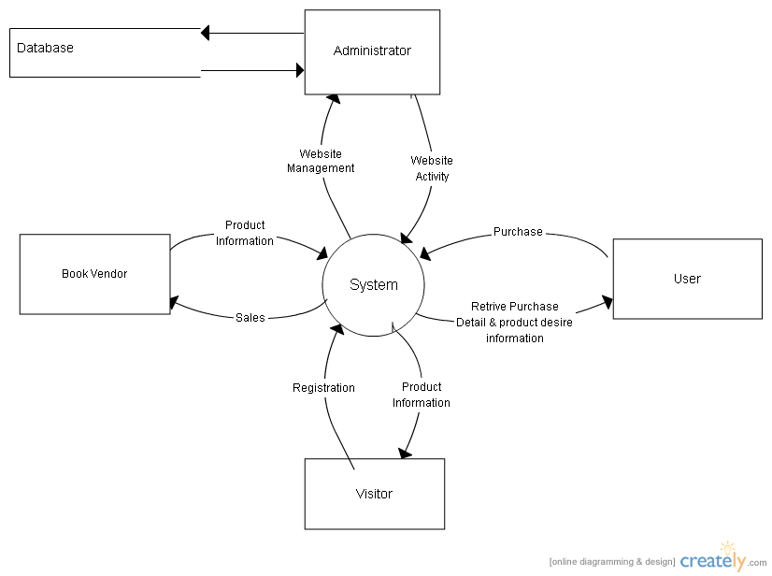

**ER Diagram**

* Captures entities like Users, Products, Suppliers, and Orders. It provides a clear visualization of relationships and dependencies within the system.
* 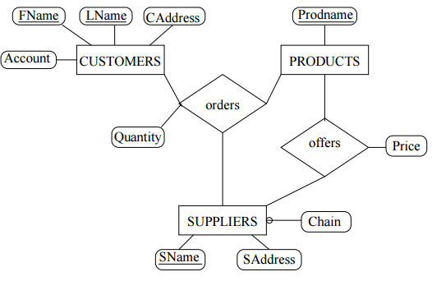

**Use Case Diagram**

* Includes scenarios for adding products, updating stock, generating reports, and managing suppliers. It highlights key functionalities and user interactions.

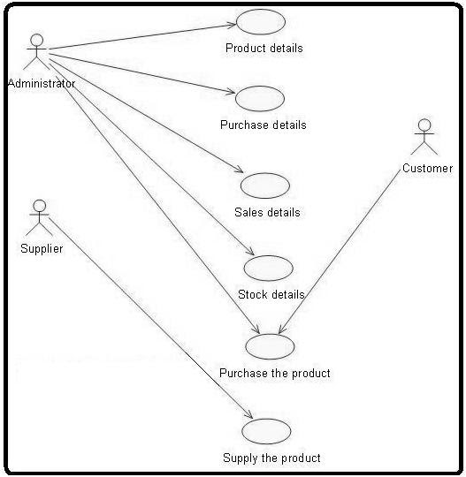

**Activity Diagrams**

* Visual representation of workflows, including stock updates and purchase order processing, ensuring clarity in operation sequences.

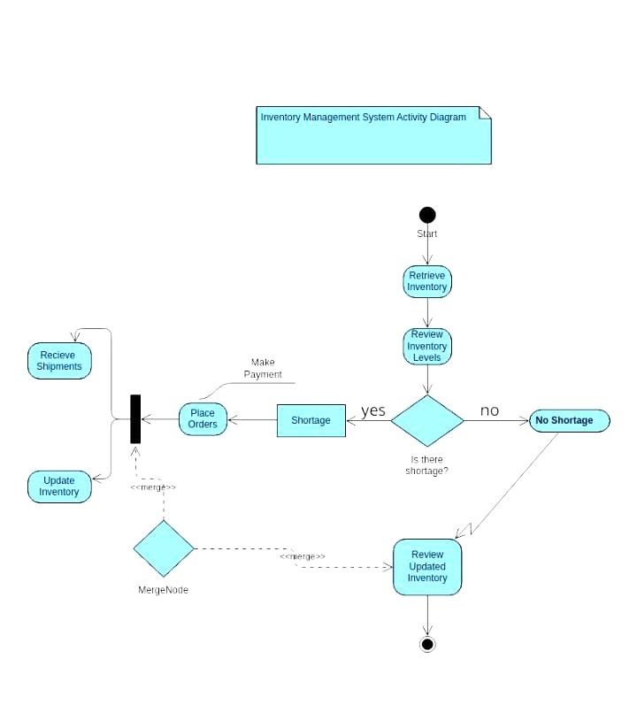

**Chapter 4**

**Snapshots of the System**

1. **Login Screen**: Allows secure access with multi-factor authentication.

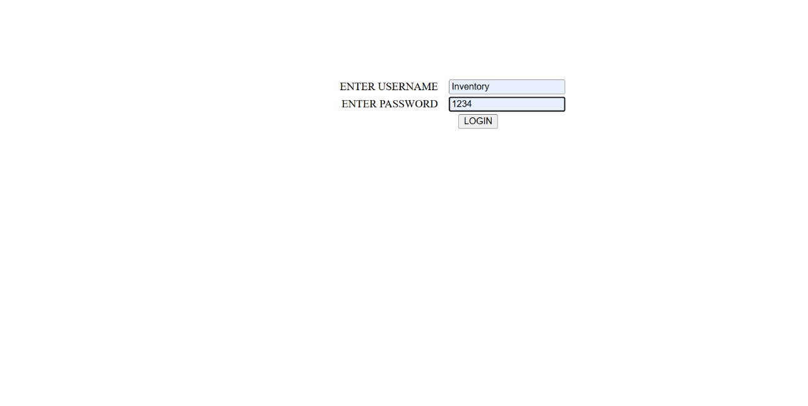

**Dashboard**: Displays stock levels, alerts, and recent activity summaries.

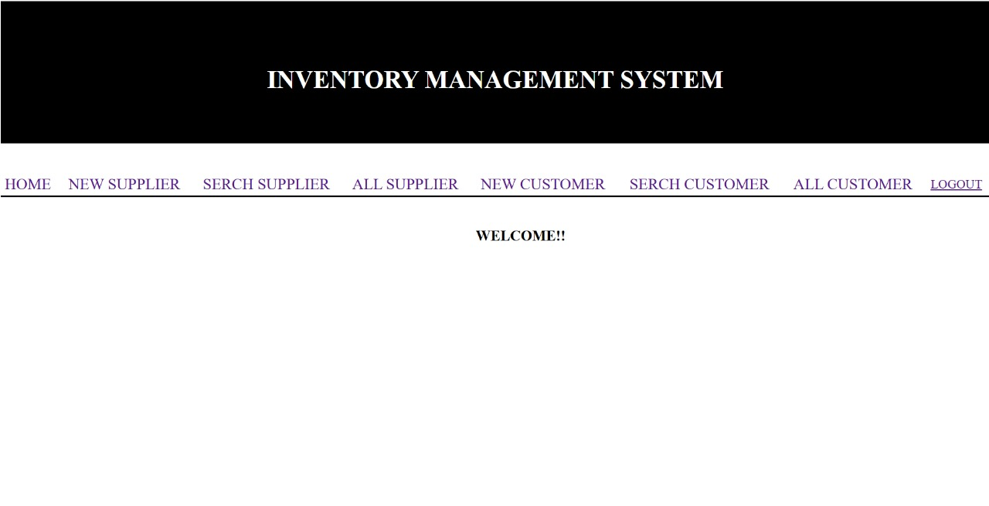

**Supplier Details**: Add or update supplier details .

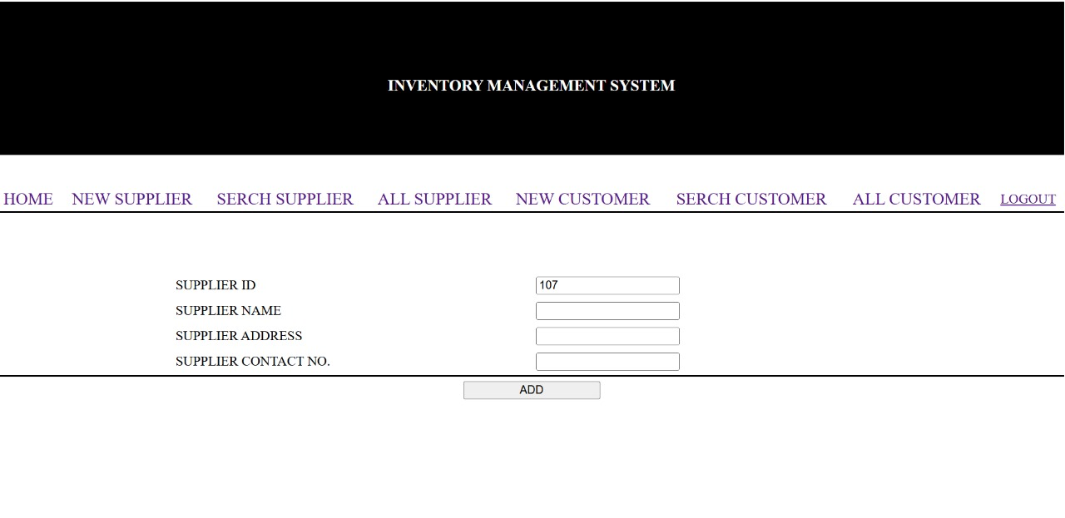

**Customer Management**: Record and view Customer information

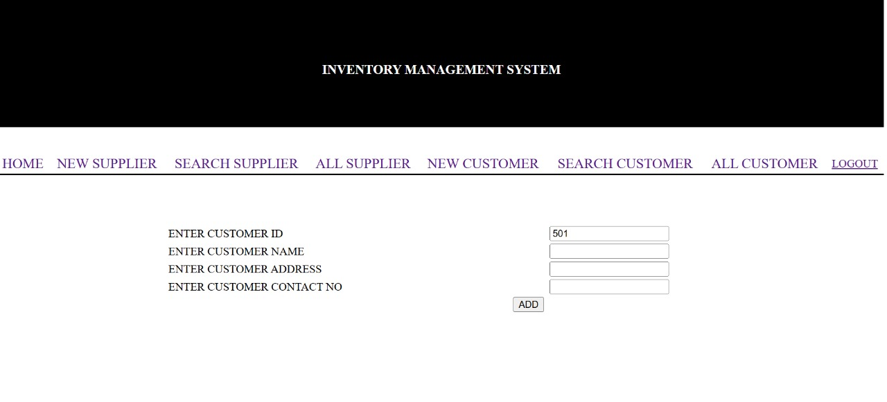

**Database:**

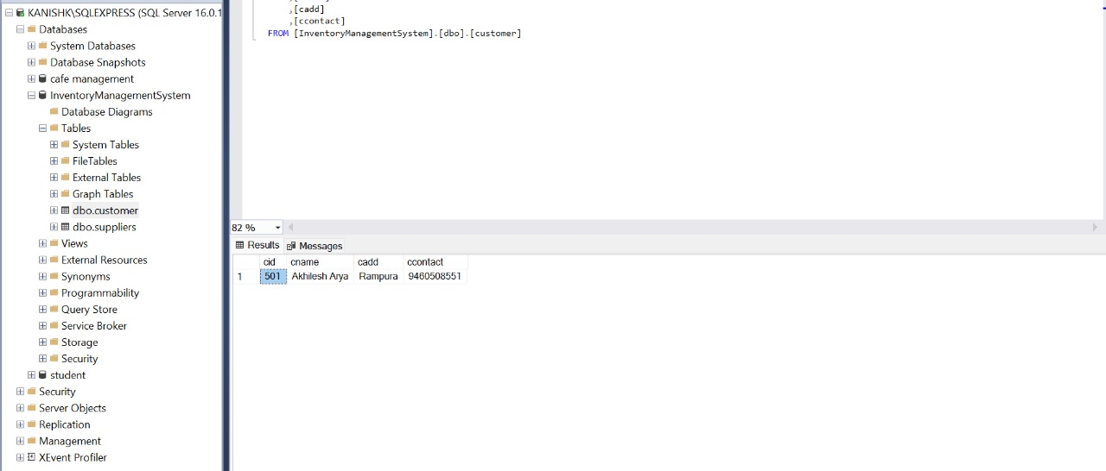

**Chapter 5**

**Future Scope for Enhancement**

**The system can be extended to include:**

* Integration with e-commerce platforms for real-time order and inventory sync.
* Support for barcode scanning and RFID tagging to enhance inventory accuracy.
* Multi-language support for global users, catering to diverse business needs.
* Advanced analytics using AI/ML for predictive insights and automated decision-making.
* Cloud deployment for improved scalability and accessibility.
* Integration with financial systems for automated accounting and budget tracking.

**Chapter 6**

**Conclusion**

* The Inventory Management System addresses inefficiencies in traditional inventory practices. It ensures accurate tracking, efficient procurement, and actionable insights. By automating key processes, the system enhances productivity, reduces errors, and empowers businesses to make informed decisions. It is a comprehensive solution that caters to businesses of varying scales, equipping them with the tools needed for sustainable growth.
* The system’s adaptability and scalability make it a future-proof choice for organizations looking to modernize their inventory management practices. It bridges the gap between operational requirements and technological capabilities, delivering value across all aspects of inventory control.

**References**

1. https://docs.microsoft.com/dotnet
2. https://www.sqlshack.com
3. https://developer.mozilla.org